EFB 437/637 – Plant Propagation
Spring Semester 2023 – Prior Knowledge Survey

Name_______________________________________________________

It’s quite possible that you’re coming into this class with a better understanding of plant propagation terminology, concepts and techniques than you realize. Of course, it’s also possible (probably even likely) that while you may know how to sow seeds or root stem cuttings of some plants in a glass of water, you may not understand seed germination or stem cutting rooting processes well enough to successfully germinate the seed or root stem cuttings of hundreds of species of plants.

The intent of this exercise, therefore, is to get a sense of your current understanding of several key plant propagation concepts right now – at the beginning of the semester.

I’ll keep these surveys and return them to you at the end of the semester – right after you’ve completed the same survey. Hopefully you’ll find that the end-of-the semester survey will be much easier to complete. After all, you will have been exposed to these concepts many times throughout the semester.

So, let’s get started (please complete one of the three options offered below) . . . . . . .

Craft an accurate, concise, and interesting one (or two, or three) paragraph plant propagation-related “story” that incorporates all five of the following concepts: seedling life cycle, clonal life cycle, seed dormancy, geophyte(s), cone of juvenility.

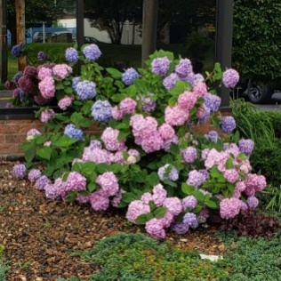
One of your friends was out for a walk and was blown away by a bigleaf hydrangea (Hydrangea macrophylla) in full bloom (see picture at right). She assumes – correctly – that it can be propagated by stem cuttings. She knows that you’re taking Plant Propagation this semester and wants you to teach her how to propagate the plant by stem cuttings. Please provide her with detailed instructions that will ensure her success.

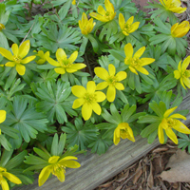
The same friend is very interested in germinating seed of winter aconite (Eranthis hyemalis) under florescent lights in his apartment. This early spring-blooming geophyte (at right) emerges from small, non-descript tubers and produces several dozen seed per bloom. Please provide him with detailed instructions that will ensure his success.

